|  |  |
| --- | --- |
| **Ex no : 7** | **Create story from map view with valid reasons** |
| **Date :** |

**AIM**

To create story from map view for a selected data source with valid reasons.

**PROCEDURE**

Step 1: Import the super store data to tableau desktop from

C:\Program Files\Tableau\Tableau Prep Builder 2023.2\help\Samples\en_US

Step 2: Create the charts that are needed by choosing attributes (Location attribute should be there)

Step 3: Connect to the tableau server using your tableau login

Step 4: In left side pane, double click on the data story icon and configure dialog box will appear

Step 5: In views, choose the work sheet for which the story has to be created.

Step 6: In fields, select the fields on which the story has to flow and create a measure on basis the story has to flow (Eg: AVG(field_name).

Step 7: In Story, Select the type of story to generate. Most probably select continues stories type and give done. Story will appear on left side.

Step 8: We can change the characteristics, Analytics and Display of your choice from the settings in the story.

**OUTPUT**

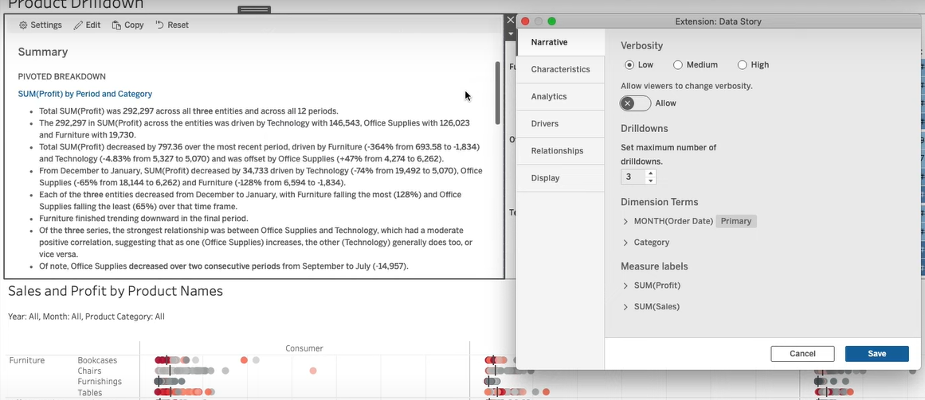

**RESULT**

Thus story from map view for a selected data source with valid reasons has been created successfully.